Programming Assignment (PowerPaint)

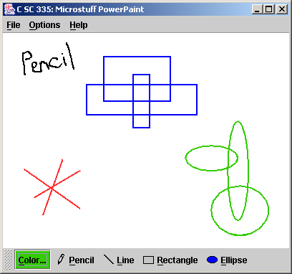
Program Description:
This assignment is designed to test your continued understanding of writing graphical applications in Java. The new key concepts are 2D graphics, mouse events, and some new Swing components.

GUI Appearance:
When the PowerPaint program runs, your main window should appear and should have the following properties:
- The window title should be "PowerPaint"
- The window should be sized to fit the preferred size of the components in it (using pack) and should be resizable.
- When the window is closed, the program should terminate.
- Below are some screen shots of the window in various states:
Initial appearance:  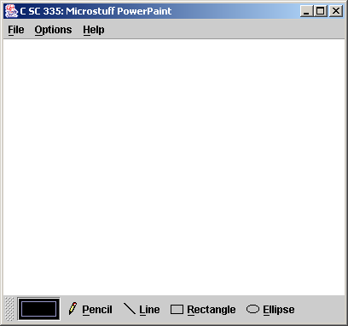 | Doodle and resize:  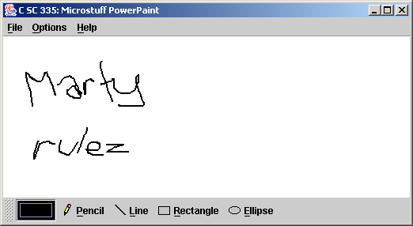 | Resize and move toolbar:  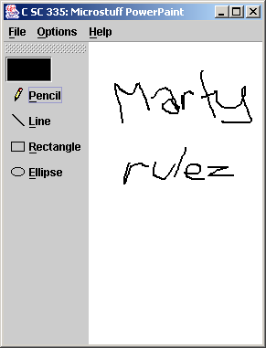 | Turn on grid:  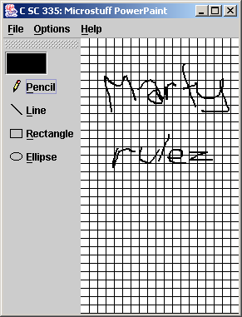

The window should have a menu bar with the following items. Mnemonics are underlined:
File
Clear (completely erases the current drawing image)
--- (separator)
Exit (exits the program)
Options
Grid (a check box menu item; when checked, a grid of black lines every 10 pixels, 1 pixel
thick, should cover the drawing panel, on top of all drawn items)
Thickness
1 (a radio button item; sets future drawn items to have 1 pixel stroke thickness)
2 (a radio button item; sets future drawn items to have 2 pixel stroke thickness)
4 (a radio button item; sets future drawn items to have 4 pixel stroke thickness)
The initial thickness is 2. Changing the thickness affects future drawn items but not those that are already drawn.
Help
About... (pops up an option pane with a about message of your choice, such as
"TCSS 305 PowerPaint, v1.0")

Components and Event-handling:
The window should contain the following components:
- A drawing panel in the center of the window, in which the user can draw with a pencil, lines, and/or shapes. The drawing panel should listen for mouse activity and draw the appropriate item using the currently selected drawing tool. The drawing panel's preferred size is 400 pixels wide and 300 pixels high, and its background color is white. As the window resizes, the panel should grow to fill available space. The panel is initially empty, being entirely white when it first appears on screen.
- A toolbar (JToolBar) with five buttons in horizontal orientation in the south region of the window. The first is a standard button for selecting colors, and the others are radio buttons representing tools that can be used to draw. Exactly one tool is selected at all times. The initially selected tool when the program loads should be the Pencil.
- Color button: Text: "Color..."
This is a standard button, not a radio button like the tools. The background color of this button should always be the same as the currently selected color. Clicking this button causes a color chooser to pop up. The color the user chooses is now the currently selected color, which should be used as the color for all future pencil / line / shape drawing. Upon selection of a new color, this button's background color should also become the new currently selected color.
Note that changing the selected color does not retroactively change the color of past drawn items. The initial color is black, and therefore the button should appear with initial background color of black.
- Pencil tool: Text: "Pencil"
Draws a freeform curve on the drawing panel in the currently selected color. After selecting this tool, pressing any mouse button in the drawing panel begins pencil drawing. As the mouse is dragged, the pencil tool draws a solid path through where the mouse is moving. When the mouse button is released, pencil drawing stops. This is the initially selected tool.
- Line tool: Text: "Line"
Draws a line on the drawing panel in the currently selected color. After selecting this tool, pressing any mouse button in the drawing panel begins line drawing by anchoring the line's first point. As the mouse is dragged, the line tool maintains a "hovering" line following the mouse, from the first anchored point to the mouse's current location. When the mouse button is released, the line is placed onto the panel and the "hover" stops following the mouse.
- Rectangle tool: Text: "Rectangle"
Draws a rectangle on the drawing panel in the currently selected color. After selecting this tool, pressing any mouse button in the drawing panel begins rectangle drawing by anchoring one of the rectangle's corner points. As the mouse is dragged, the line tool maintains a "hovering" rectangle following the mouse, from the first anchored point to the mouse's current location. When the mouse button is released, the rectangle is placed onto the panel and the "hover" stops following the mouse.
- Ellipse tool: Text: "Ellipse"
Draws an ellipse on the drawing panel in the currently selected color. After selecting this tool, pressing any mouse button in the drawing panel begins ellipse drawing by anchoring one of the ellipse's bounding box's corner points. As the mouse is dragged, the line tool maintains a "hovering" ellipse following the mouse, with its bounding box from the first anchored point to the mouse's current location. When the mouse button is released, the ellipse is placed onto the panel and the "hover" stops following the mouse.

Implementation Guidelines and Hints:
Implement your main drawing area as a class that extends JPanel. To this panel you should attach mouse listeners to detect mouse movement and button presses. Put your tool buttons and thickness menu items into button groups, so that only one may be selected at a time.
You should probably store a collection of all shapes that have ever been drawn, along with each one's color and stroke width. (Maybe you should make a class to store these related items.)
Implement the pencil by drawing a line between each pair of points the mouse touches. A java.awt.geom.GeneralPath works well.
Note that rectangles and ellipses may be drawn by dragging the mouse upward or leftward as well as downward and rightward -- this may not work properly for you unless you handle it specially.
You can (optionally) smoothe the graphics on your panel by calling the following command on your Graphics2D object, which "anti-aliases" the panel (blurs the pixels):
g2.setRenderingHint(RenderingHints.KEY_ANTIALIASING, RenderingHints.VALUE_ANTIALIAS_ON);

Extra Credit:
For +1 extra point, you may optionally also turn in a screen shot of a drawing you have made using your PowerPaint program. Capture it by pressing [Alt-PrintScreen] when the PowerPaint window is active, then pasting into an actual paint program like Microsoft Paint (Start -> Programs -> Accessories -> Paint, from a Windows XP machine), then saving as 24-bit Bitmap (BMP) format. Name your file drawing.bmp. Student drawings may be posted on the course web site.
Also, for +1 extra point, you may add an additional tool or substantial feature to the program. The feature should be non-trivial; for example, a rounded rectangle tool wouldn't get credit, because it's identical to the existing Rectangle tool except for using a RoundedRectangle2D object. Feel free to ask the instructor whether your proposed extra feature would merit the extra point. You may implement more than one extra feature, but you can only get +1 extra credit feature point.

Submission and Grading:
This assignment is due in two parts. For the first part, the only functionality that needs to work is the ability to draw on the screen using the Line tool, in the color black. The menus, tool bar, and color setting do not need to work, but it should be possible to drag the mouse and see the line in progress and have the line remain there when the user lets go of the button. Your first turnin will be judged only on external correctness. For the second part, all features must be finished, and you will be graded on both external and internal correctness.
Turn in all Java files you wrote for this program.
The "external correctness" of your final submission will be graded on the GUI's behavior, which is observed by running the GUI, clicking various buttons and examining the result. Your GUI should match the expected layout and should be positioned, sized, and resize identically to expectations. Exceptions should not occur under normal usage. Your program should not produce any console output.
The "internal correctness" of your final submission will be graded on whether you follow the program specification above, the presence of reasonable brief comments in your source code (a short header with your name and course on each class; a header on each method; and a comment on particularly complex code sections), the use of meaningful identifier names, encapsulation, avoiding redundancy and kludgey solutions, and general spacing and indentation of your code.

